SILVERTON

Nutanix Operations Runbook

Document Category – CONFIDENTIAL

Document Version – 0.1

|  |
| --- |
| **Notice** |
| © 2024 Tata Consultancy Services Limited  This is a controlled document. Unauthorized access, copying, replication or usage for a purpose other than for which it is intended, are prohibited.  All trademarks that appear in the document have been used for identification purposes only and belong to their respective companies. |

|  |
| --- |
| **Tata Code of Conduct** |
| We, in our dealings, are self-regulated by a Code of Conduct as enshrined in the Tata Code of Conduct. We request your support in helping us adhere to the Code in letter and spirit. We request that any violation or potential violation of the Code by any person be promptly brought to the notice of the Local Ethics Counselor or the Principal Ethics Counselor or the CEO of TCS. All communication received in this regard will be treated and kept as confidential. |

**Document Release Note**

Customer :  Cigna

Project :  Silverton

**Document Details**

|  |  |  |
| --- | --- | --- |
| **Name** | **Version Number** | **Description** |
| Silverton Nutanix Operations Runbook | 0.1 | Runbook with the complete information on the Operations aspect of Silverton Nutanix environment. |

**Revision Details**

|  |  |  |  |  |
| --- | --- | --- | --- | --- |
| **Action Taken  (Add/Del/Change)** | **Previous Page Number** | **New Page Number** | **Revision Description** | **Date** |
| New Document created |  |  |  | 10/15/2024 |

These are confidential documents. Unauthorized access or copying is prohibited.

Reviewed by: Approved by:

Date: Date:

**Purpose**

The purpose of this document is to provide complete details on how to manage the Silverton Nutanix Environment.

Detailed below are all the steps required to manage Nutanix devices, troubleshoot failures, manage alerts, perform hardware replacements and so on

**Intended Audience**

Nutanix Operations team

Contents

1 Document Information 5

2 Version History and Approval 5

3 Distribution and Sign-off List 5

4 Glossary 5

5 Introduction 6

5.1 Nutanix Team members 6

5.2 Nutanix Vendor Support 6

5.2.1 Vendor Portal Registration Steps 6

5.2.2 Nutanix Case Creation: 8

5.3 Dell Vendor Support 10

5.3.1 Vendor Portal Registration Steps 10

5.3.2 Dell Case Creation: 11

5.4 Nutanix Monitoring 14

5.5 Silverton Nutanix Environment 14

5.5.1 Data Center Layout 14

5.5.2 Nutanix Cluster Details 15

5.6 Prism Element Overview and Licensing. 17

5.7 Nutanix Health check 20

5.8 Alert Definition 22

6 Nutanix Cluster Management 23

6.1 Adding / Exiting Node in Maintenance Mode 23

6.2 Storage Container Creation 26

6.3 Node Removal 30

6.4 Node Addition 30

6.5 Expansion of cluster 31

6.6 AOS Upgrade 33

6.7 Hypervisor Upgrade 37

6.8 LCM Upgrade 40

6.9 Renewing Prism SSL Certificates. 44

6.10 TPM-ESXI Security Key Recovery Process 45

6.11 Server Device Issue 46

6.11.1 Memory Failure 47

6.11.2 HDDFailure 48

7 Nutanix basic command for troubleshooting. 49

8 Link to other generic issues and troubleshooting KB articles 49

# Document Information

|  |  |
| --- | --- |
| **Author** | Nilesh Gaikwad |
| **Contributor** |  |
| **Document Name** | Silverton Nutanix Operations Runbook |

# Version History and Approval

|  |  |  |  |
| --- | --- | --- | --- |
| **Date** | **Version No.** | **Author** | **Reason for Change** |
|  |  |  |  |
|  |  |  |  |

# Distribution and Sign-off List

|  |  |  |  |
| --- | --- | --- | --- |
| **Name** | **Area** | **Action Required** | **Approval Date** |
|  |  |  |  |
|  |  |  |  |

# Glossary

|  |  |
| --- | --- |
| **Abbreviation/Acronym** | **Description** |
| DC | Datacenter |
| IAD | Ashburn Datacenter – Non-Production |
| EWR | Piscataway Datacenter – Production |
| CVM | Storage Controller Virtual Machine |
| RF | Replication Factor |
| IDRAC | Integrated Dell Remote Access Controller |
| RMA | Return Material Authorization |
| PC | Prism Central |
| PE | Prism Element |

# Introduction

This document provides details about the Nutanix infrastructure managed through Prism Element in Silverton Environment.

This includes the infrastructure details, delivery approach, failure handling and all identified hardware and software alert management.

## Nutanix Team members

Nutanix Team Email: tcsnutanixteam@evernorth.com

|  |  |  |
| --- | --- | --- |
| **Name** | **E-mail** | **Location** |
| Nilesh Gaikwad | [nilesh.gaikwad@evernorth.com](mailto:nilesh.gaikwad@evernorth.com) | Offshore |
| Shankar Krishnan Sureshkumar | [shankar.krishnansureshkumar@evernorth.com](mailto:shankar.krishnansureshkumar@evernorth.com) | Offshore |
| Shree Nandhini | [shree.nandhinis@cigna.com](mailto:shree.nandhinis@cigna.com) | Offshore |
| Daniel Salud | [daniel.salud@evernorth.com](mailto:daniel.salud@evernorth.com) | Onshore |

## Nutanix Vendor Support

Use the below URL to create an account on the Nutanix support site using the Cigna e-mail ID.

https://portal.nutanix.com/

### Vendor Portal Registration Steps

* On <https://portal.nutanix.com/> home page, click on the “Sign up now”

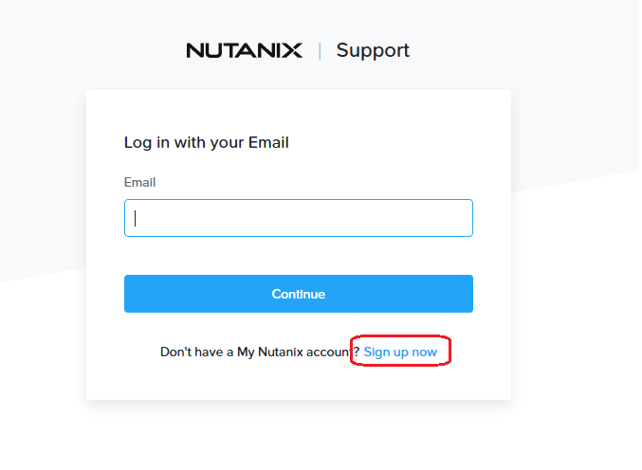

* Fill in the Data with your First Name, Last Name, Company name,Job title, Phone number, country and Email ID to Complete Your Profile & then Click “Submit.”

* You will receive an email asking you to confirm your registration.
* Once you respond to the email you are officially registered with Nutanix
* This Nutanix Support portal to create and manage Service requests, search for KB articles, whitepapers and manage Licensing etc.

### Nutanix Case Creation:

To create a support case with Nutanix, you can:

* Log in to the [Nutanix support portal](https://www.nutanix.com/support-services/product-support/getting-started-with-support)
* Click on smart support button Left side pane and then cases.

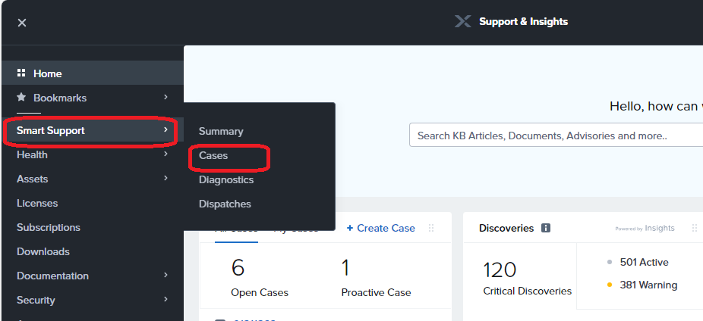

* Click Create Case

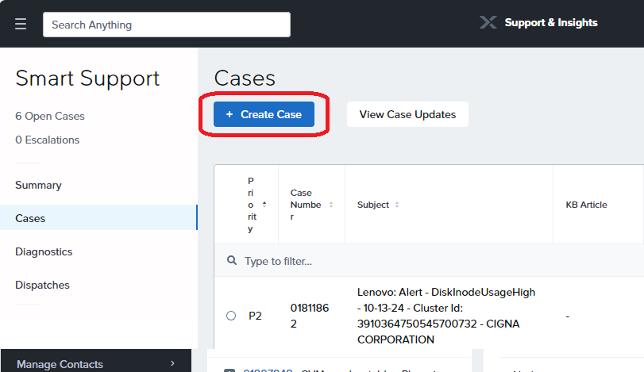

* + Complete the form, including:
  + Cluster name
  + Hypervisor version
  + AOS version
  + Priority

* Click Next Button, after workflow will show recommended solution if it regarding your issue try to troubleshoot otherwise Press **Submit Ticket.**

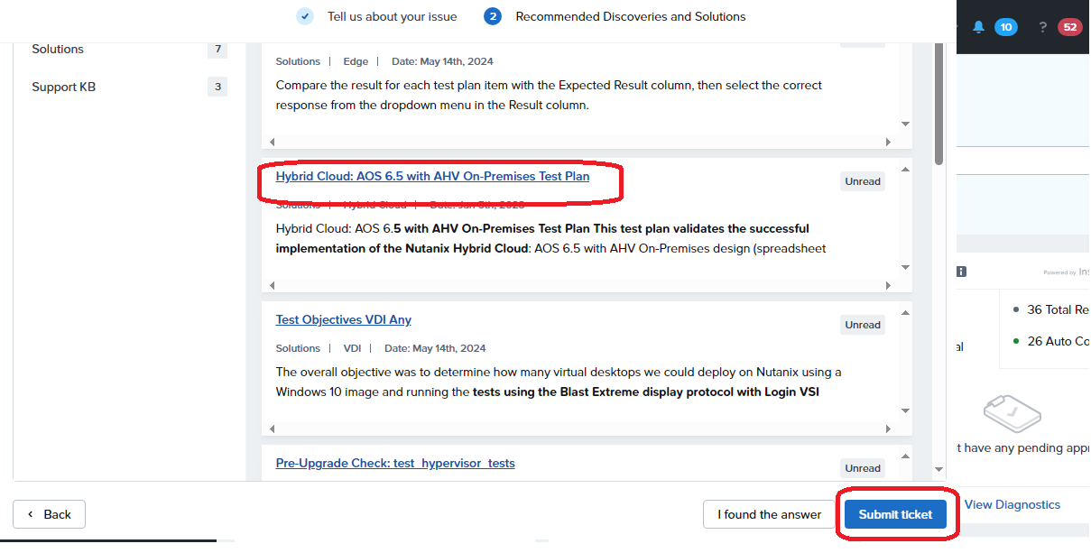

## Dell Vendor Support

Use the below URL to create an account on the Dell support site using the Cigna e-mail ID.

https://www.dell.com/support/home/en-us

### Vendor Portal Registration Steps

* On [Support | Dell US](https://www.dell.com/support/home/en-us) home page, click on the “Create an account”

* After clicking Create an account, Sign up form will appear.

* Give Details First name, Last name, email address and create your account with mail id.

### Dell Case Creation:

To create a support case with Dell, you can:

* Go and sign in to the Dell Online Support site at <https://www.dell.com/support/incidents-online/contactus>

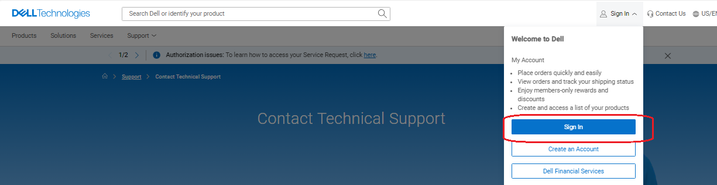

* Identify your Dell device by selecting it from the list or by entering the service tag, Express Service Code, Serial Number, or Model number

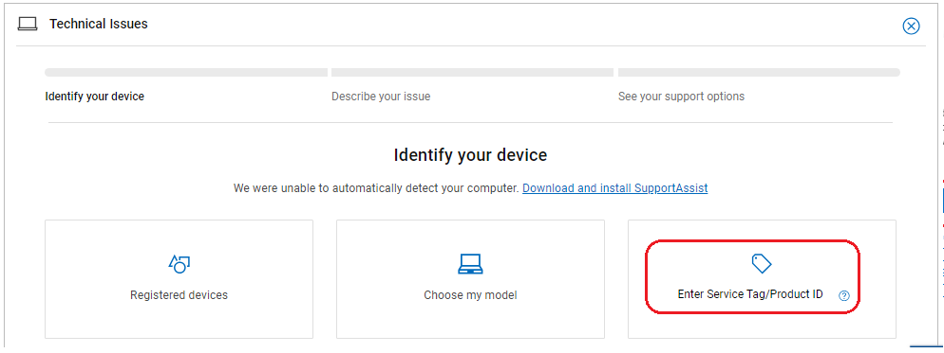

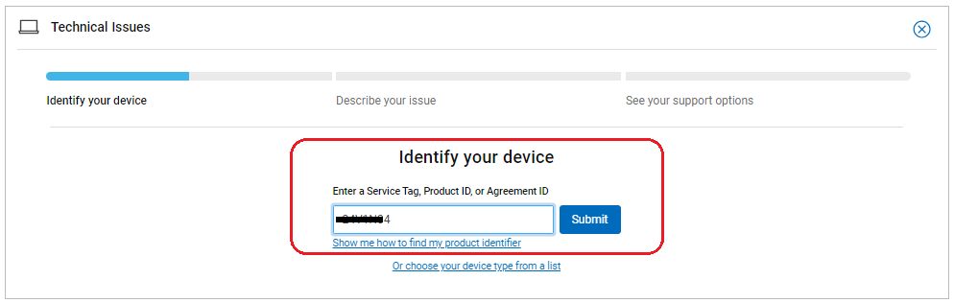

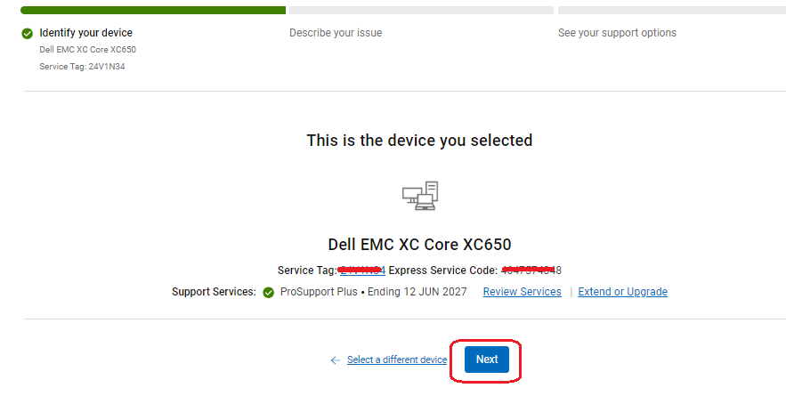

* Select the symptom or component that corresponds to the issue from the drop-down list

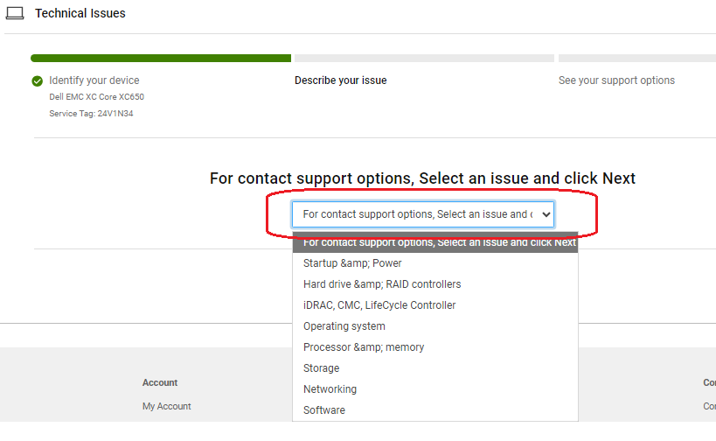

* Click Create Service Request

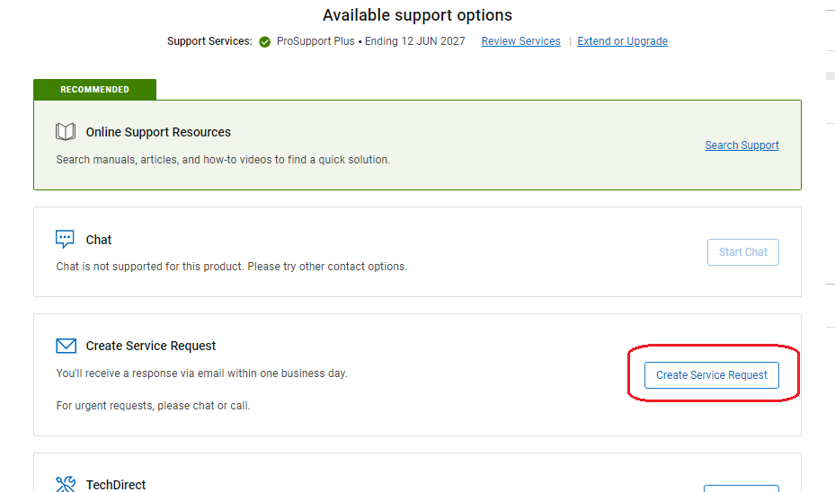

* Enter the details in the form and click Submit

## Nutanix Monitoring

We have following documentation for monitoring purpose only. Please follow the same.

[Nutanix Monitoring Document.docx](https://cignatlp.sharepoint.com/:w:/r/sites/GovernmentDivestitureMigration/Shared%20Documents/Datacenter/Runbook%20and%20OPS/Compute/Nutanix/Nutanix%20Monitoring%20Document.docx?d=wfd636f6a6f874fc586b2b96c26e8802c&csf=1&web=1&e=ZScLZJ)

## Silverton Nutanix Environment

Nutanix environment consists of Dell XC 650 Rack Servers which are managed through Nutanix PE/PC and through iDrac across two datacenters. Nutanix Prism provides central access to configure, monitor, and manage virtual environments.  And iDRAC is used for secure local and remote server management and helps IT administrators deploy, update and monitor Dell servers anywhere, anytime.

|  |  |  |
| --- | --- | --- |
| **Datacenter (DC)** | **Environment** | **Rack Servers** |
| EWR (Piscataway DC) | Production | 21 |
| IAD (Ashburn DC) | Non-Production | 21 |

### Data Center Layout

Physical Address and DC engineer details are mentioned below to verify physical health and/or any basic troubleshooting of Dell Servers which does not require vendor engagement.

|  |  |  |  |  |
| --- | --- | --- | --- | --- |
| **DC** | **Physical Address** | **DC Engineer Name** | **DC Engineer Email** | **DC Engineer Phone Number** |
| IAD | Cigna Corporate Services  C/O Digital Realty S212  44274 Round Table Piz, Ashburn, VA 20147 | Bhaumik Desai | [Bhaumik.Desai@evernorth.com](mailto:Bhaumik.Desai@evernorth.com) | +1 706-615-8521 |
| EWR | Cigna Corporate Services C/O Digital Realty S130 365 S Randolph Ville Rd, Piscataway, NJ 08854 | Talvir Singh | [Talvir.Singh@evernorth.com](mailto:Talvir.Singh@evernorth.com) | +1 8138049418 |

* Nutanix devices are listed in the below spreadsheet along with the DC layout.

IAD DC Layout – [IAD_Nutanix_Datacenter_Layout.xlsx](https://cignatlp.sharepoint.com/:x:/r/sites/GovernmentDivestitureMigration/Shared%20Documents/Datacenter/Runbook%20and%20OPS/Compute/Nutanix/IAD_Nutanix_Datacenter_Layout.xlsx?d=w99e706bad4d44bec844aa89fad367c95&csf=1&web=1&e=HHfZdN)

EWR DC Layout - [EWR_Nutanix_Datacenter_Layout.xlsx](https://cignatlp.sharepoint.com/:x:/r/sites/GovernmentDivestitureMigration/Shared%20Documents/Datacenter/Runbook%20and%20OPS/Compute/Nutanix/EWR_Nutanix_Datacenter_Layout.xlsx?d=wcbb3b66b3c444ca698bef9e9fb0475f4&csf=1&web=1&e=7WFt9z)

### Nutanix Cluster Details

**IAD-W-PRD-VDI-01-NX:**

|  |  |  |  |  |  |
| --- | --- | --- | --- | --- | --- |
| **IAD-W-PRD-VDI-01-NX Nutanix Cluster** | | | | | |
| **Management Network** | | | | **IPMI / OOB** | |
| (Must be routable) - VLAN – 3218 | | | | (Must be routable) - VLAN – 3201 | |
| **Hypervisor IP** | **Hypervisor Name** | **Storage Controller** | | **Hypervisor** | |
| 10.118.33.11 | IADDESX0001 | 10.118.33.12 | NTNX-3WVWM34-A-CVM | 10.118.5.101 | IADDESX0001-IDRAC |
| 10.118.33.13 | IADDESX0002 | 10.118.33.14 | NTNX-5WVWM34-A-CVM | 10.118.5.102 | IADDESX0002-IDRAC |
| 10.118.33.15 | IADDESX0003 | 10.118.33.16 | NTNX-4WVWM34-A-CVM | 10.118.5.103 | IADDESX0003-IDRAC |
| 10.118.33.17 | IADDESX0004 | 10.118.33.18 | NTNX-6WVWM34-A-CVM | 10.118.5.104 | IADDESX0004-IDRAC |
| 10.118.33.19 | IADDESX0005 | 10.118.33.20 | NTNX-CWVWM34-A-CVM | 10.118.5.105 | IADDESX0005-IDRAC |
| 10.118.33.21 | IADDESX0006 | 10.118.33.22 | NTNX-DWVWM34-A-CVM | 10.118.5.106 | IADDESX0006-IDRAC |
| 10.118.33.23 | IADDESX0007 | 10.118.33.24 | NTNX-GWVWM34-A-CVM | 10.118.5.107 | IADDESX0007-IDRAC |
| 10.118.33.25 | IADDESX0008 | 10.118.33.26 | NTNX-FWVWM34-A-CVM | 10.118.5.108 | IADDESX0008-IDRAC |
| 10.118.33.27 | IADDESX0009 | 10.118.33.28 | NTNX-HWVWM34-A-CVM | 10.118.5.109 | IADDESX0009-IDRAC |
| 10.118.33.29 | IADDESX0010 | 10.118.33.30 | NTNX-BWVWM34-A-CVM | 10.118.5.110 | IADDESX0010-IDRAC |
| 10.118.33.31 | IADDESX0011 | 10.118.33.32 | NTNX-9WVWM34-A-CVM | 10.118.5.111 | IADDESX0011-IDRAC |
| 10.118.33.33 | IADDESX0012 | 10.118.33.34 | NTNX-7WVWM34-A-CVM | 10.118.5.112 | IADDESX0012-IDRAC |
| 10.118.33.35 | IADDESX0013 | 10.118.33.36 | NTNX-8WVWM34-A-CVM | 10.118.5.113 | IADDESX0013-IDRAC |
|  | | | | | |
| **Prism Element IP** | | **10.118.33.100** | **Subnet Mask** | | **255.255.254.0** |
| **Subnet Mask** | | **255.255.255.0** | **Default Gateway** | | **10.118.4.1** |
| **Default Gateway** | | **10.118.33.1** |  | | |
| **Prism Element FQDN** | | **IAD-W-PRD-VDI-01-NX.healthspring.inside** | | | |
| **DNS Server** | | **10.118.24.140** | | | |
| **NTP Server** | | **ntp2.healthspring.inside** | | | |
| **Replication Factor** | | **RF3** | | | |

**IAD-W-PRD-VDI-02-NX:**

|  |  |  |  |  |  |
| --- | --- | --- | --- | --- | --- |
| **IAD Nutanix Cluster 13 Node** | | | | | |
| **Management Network** | | | | **IPMI / OOB** | |
| (Must be routable) - VLAN – 3218 | | | | (Must be routable) - VLAN - 3201 | |
| **Hypervisor IP** | **Hypervisor Name** | **Storage Controller** | | **IPMI IP** | **IPMI FQDN** |
| 10.118.33.37 | IADDESX0014 | 10.118.33.38 | NTNX-3D8WZ44-A-CVM | 10.118.5.114 | IADDESX0014-IDRAC |
| 10.118.33.39 | IADDESX0015 | 10.118.33.40 | NTNX-5D8WZ44-A-CVM | 10.118.5.115 | IADDESX0015-IDRAC |
| 10.118.33.41 | IADDESX0016 | 10.118.33.42 | NTNX-1D8WZ44-A-CVM | 10.118.5.116 | IADDESX0016-IDRAC |
| 10.118.33.43 | IADDESX0017 | 10.118.33.44 | NTNX-2D8WZ44-A-CVM | 10.118.5.117 | IADDESX0017-IDRAC |
| 10.118.33.45 | IADDESX0018 | 10.118.33.46 | NTNX-HC8WZ44-A-CVM | 10.118.5.118 | IADDESX0018-IDRAC |
| 10.118.33.47 | IADDESX0019 | 10.118.33.48 | NTNX-GC8WZ44-A-CVM | 10.118.5.119 | IADDESX0019-IDRAC |
| 10.118.33.49 | IADDESX0020 | 10.118.33.50 | NTNX-4D8WZ44-A-CVM | 10.118.5.120 | IADDESX0020-IDRAC |
| 10.118.33.51 | IADDESX0021 | 10.118.33.52 | NTNX-JC8WZ44-A-CVM | 10.118.5.121 | IADDESX0021-IDRAC |
| **Subnet Mask** | | **255.255.255.0** | **Subnet Mask** | | **255.255.254.0** |
| **Default Gateway** | | **10.118.33.1** | **Default Gateway** | | **10.118.4.1** |
| **Prism Element FQDN** | | **10.118.33.105** | **Prism Element FQDN** | **IAD-W-PRD-VDI-02-NX.healthspring.inside** | |
| **DNS Server** | | **10.118.24.140** | | | |
| **LDAP** | | **ldaps://dcldap2.healthspring.inside:636** | | | |
| **NTP Server** | | **ntp2.healthspring.inside** | | | |
| **Replication Factor** | | **RF3** | | | |

**EWR:**

**EWR-W-PRD-VDI-01-NX:**

|  |  |  |  |  |  |
| --- | --- | --- | --- | --- | --- |
| **EWR Nutanix Cluster** | | | | | |
| **Management Network** | | | | **IPMI / OOB** | |
| (Must be routable) - VLAN – 218 | | | | (Must be routable) - VLAN - 201 | |
| **Hypervisor IP** | **Hypervisor Name** | **Storage Controller** | | **Hypervisor** | |
| 10.116.33.11 | EWRDESX0001 | 10.116.33.12 | NTNX-63V1N34-A-CVM | 10.116.5.101 | EWRDESX0001-IDRAC |
| 10.116.33.13 | EWRDESX0002 | 10.116.33.14 | NTNX-83V1N34-A-CVM | 10.116.5.102 | EWRDESX0002-IDRAC |
| 10.116.33.15 | EWRDESX0003 | 10.116.33.16 | NTNX-73V1N34-A-CVM | 10.116.5.103 | EWRDESX0003-IDRAC |
| 10.116.33.17 | EWRDESX0004 | 10.116.33.18 | NTNX-B3V1N34-A-CVM | 10.116.5.104 | EWRDESX0004-IDRAC |
| 10.116.33.19 | EWRDESX0005 | 10.116.33.20 | NTNX-C3V1N34-A-CVM | 10.116.5.105 | EWRDESX0005-IDRAC |
| 10.116.33.21 | EWRDESX0006 | 10.116.33.22 | NTNX-H3V1N34-A-CVM | 10.116.5.106 | EWRDESX0006-IDRAC |
| 10.116.33.23 | EWRDESX0007 | 10.116.33.24 | NTNX-J3V1N34-A-CVM | 10.116.5.107 | EWRDESX0007-IDRAC |
| 10.116.33.25 | EWRDESX0008 | 10.116.33.26 | NTNX-93V1N34-A-CVM | 10.116.5.108 | EWRDESX0008-IDRAC |
| 10.116.33.27 | EWRDESX0009 | 10.116.33.28 | NTNX-24V1N34-A-CVM | 10.116.5.109 | EWRDESX0009-IDRAC |
| 10.116.33.29 | EWRDESX0010 | 10.116.33.30 | NTNX-14V1N34-A-CVM | 10.116.5.110 | EWRDESX0010-IDRAC |
| 10.116.33.31 | EWRDESX0011 | 10.116.33.32 | NTNX-G3V1N34-A-CVM | 10.116.5.111 | EWRDESX0011-IDRAC |
| 10.116.33.33 | EWRDESX0012 | 10.116.33.34 | NTNX-D3V1N34-A-CVM | 10.116.5.112 | EWRDESX0012-IDRAC |
| 10.116.33.35 | EWRDESX0013 | 10.116.33.36 | NTNX-F3V1N34-A-CVM | 10.116.5.113 | EWRDESX0013-IDRAC |
|  | | | | | |
| **Prism Element IP** | | **10.116.33.100** | **Subnet Mask** | | **255.255.254.0** |
| **Subnet Mask** | | **255.255.255.0** | **Default Gateway** | | **10.116.4.1** |
| **Default Gateway** | | **10.116.33.1** |  | | |
| **Prism Element FQDN** | | **EWR-W-PRD-VDI-01-NX.healthspring.inside** | | | |
| **DNS Server** | | **10.116.24.140** | | | |
| **NTP Server** | | **ntp1.healthspring.inside** | | | |
| **Replication Factor** | | **RF3** | | | |

**EWR-W-PRD-VDI-02-NX:**

|  |  |  |  |  |  |
| --- | --- | --- | --- | --- | --- |
| **EWR Nutanix Cluster** | | | | | |
| **Management Network** | | | | **IPMI / OOB** | |
| (Must be routable) - VLAN - 218 | | | | (Must be routable) - VLAN – 201 | |
| **Hypervisor IP** | **Hypervisor Name** | **Storage Controller** | | **IPMI IP** | **IPMI FQDN** |
| 10.116.33.37 | EWRDESX0014 | 10.116.33.38 | [NTNX-FD8WZ44-A-CVM](javascript:void(0)) | 10.116.5.114 | EWRDESX0014-IDRAC |
| 10.116.33.39 | EWRDESX0015 | 10.116.33.40 | [NTNX-BD8WZ44-A-CVM](javascript:void(0)) | 10.116.5.115 | EWRDESX0015-IDRAC |
| 10.116.33.41 | EWRDESX0016 | 10.116.33.42 | [NTNX-DD8WZ44-A-CVM](javascript:void(0)) | 10.116.5.116 | EWRDESX0016-IDRAC |
| 10.116.33.43 | EWRDESX0017 | 10.116.33.44 | [NTNX-CD8WZ44-A-CVM](javascript:void(0)) | 10.116.5.117 | EWRDESX0017-IDRAC |
| 10.116.33.45 | EWRDESX0018 | 10.116.33.46 | [NTNX-7D8WZ44-A-CVM](javascript:void(0)) | 10.116.5.118 | EWRDESX0018-IDRAC |
| 10.116.33.47 | EWRDESX0019 | 10.116.33.48 | [NTNX-6D8WZ44-A-CVM](javascript:void(0)) | 10.116.5.119 | EWRDESX0019-IDRAC |
| 10.116.33.49 | EWRDESX0020 | 10.116.33.50 | [NTNX-9D8WZ44-A-CVM](javascript:void(0)) | 10.116.5.120 | EWRDESX0020-IDRAC |
| 10.116.33.51 | EWRDESX0021 | 10.116.33.52 | [NTNX-8D8WZ44-A-CVM](javascript:void(0)) | 10.116.5.121 | EWRDESX0021-IDRAC |
|  | | | | | |
| **Subnet Mask** | | **255.255.255.0** | **Subnet Mask** | | **255.255.254.0** |
| **Default Gateway** | | **10.116.33.1** | **Default Gateway** | | **10.116.4.1** |
| **Prism Element FQDN** | | **10.116.33.105** | **Prism Element FQDN** | **EWR-W-PRD-VDI-02-NX.healthspring.inside** | |
| **DNS Server** | | **10.116.24.140** | | | |
| **NTP Server** | | **ntp1.healthspring.inside** | | | |
| **LDAP** | | **ldaps://dcldap1.healthspring.inside:636** | | | |
| **Replication Factor** | | **RF3** | | | |

## Prism Element Overview and Licensing.

Prism Element is a distributed resource management platform which allows users to manage and monitor objects and services across their Nutanix environment. These capabilities are broken down into two key categories: Interfaces. HTML5 UI, REST API, CLI, PowerShell CMDlets, etc.

**Assessing Nutanix Cluster:**

* We can Access Nutanix Cluster by clutser ip/ cluster fqdn listed below.

Prism Element URL:

|  |  |
| --- | --- |
| **Datacenter (DC)** | **Nutanix Cluster FQDN** |
| EWR (Piscataway DC) PE | <https://ewr-w-prd-vdi-01-nx.healthspring.inside:9440/> |
| <https://ewr-w-prd-vdi-02-nx.healthspring.inside:9440/> |
| IAD (Ashburn DC) PE | [https://iad-w-prd-vdi-01-nx.healthspring.inside:9440](https://iad-w-prd-vdi-01-nx.healthspring.inside:9440/) |
| <https://iad-w-prd-vdi-02-nx.healthspring.inside:9440> |
| Prism Central | https://ewrntnxpc01.healthspring.inside:9440 |

* After Accessing cluster fqdn you will get following Nutanix Prism Element HomePage.

* You can use admin or your created or assigned user to login, After login you get Nutanix dashboard.

**Cluster Licensing:**

* To license the Nutanix cluster login to the Nutanix cluster, on **dashboard** click to **home** option beside the cluster name and select **“Settings”**

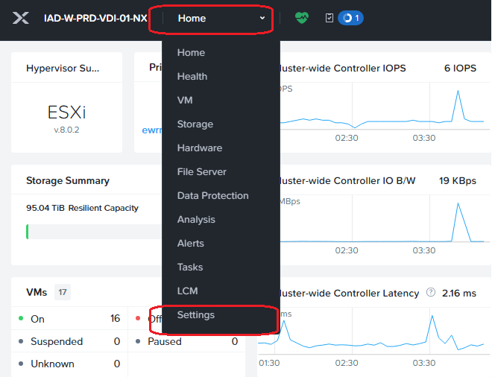

* After clicking **Settings,** Click on **Licensing** tab under general category. On Licensing page click on **Update Licenses**

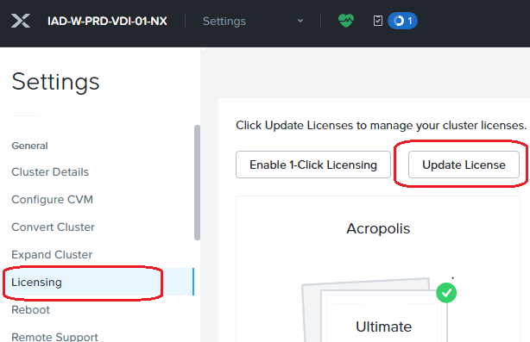

* After that click on download button to download cluster summary file which we will upload to the Nutanix Portal (portal.nutanix.com) to generate licenses for our cluster.

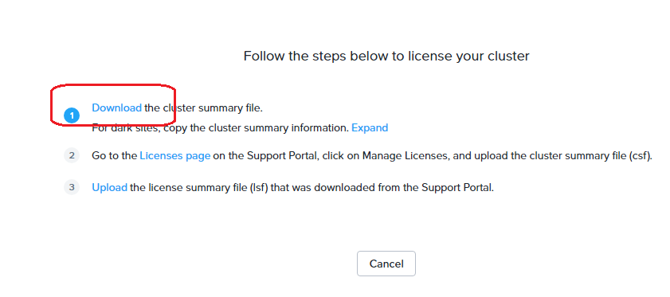

* Generate a Cluster Summary File
* Log into Nutanix License Portal
  + Follow Wizard
* Upload License File in Prism Element
* Ensure license file was applied to the cluster by reviewing "Gear/Licensing/view details" section.   For license "Type" validate "Ultimate" licenses were applied to all controller nodes in the cluster.

## Nutanix Health check

Nutanix Cluster Check (NCC) is cluster-resident software that can help diagnose cluster health and identify configurations qualified and recommended by Nutanix. NCC. Depending on the issue discovered, NCC raises an alert or automatically creates Nutanix Support cases. NCC can be run provided that the individual nodes are up, regardless of cluster state.

Monitoring Cluster Health:

From the Prism web console Dashboard page, you monitor current status of the cluster.

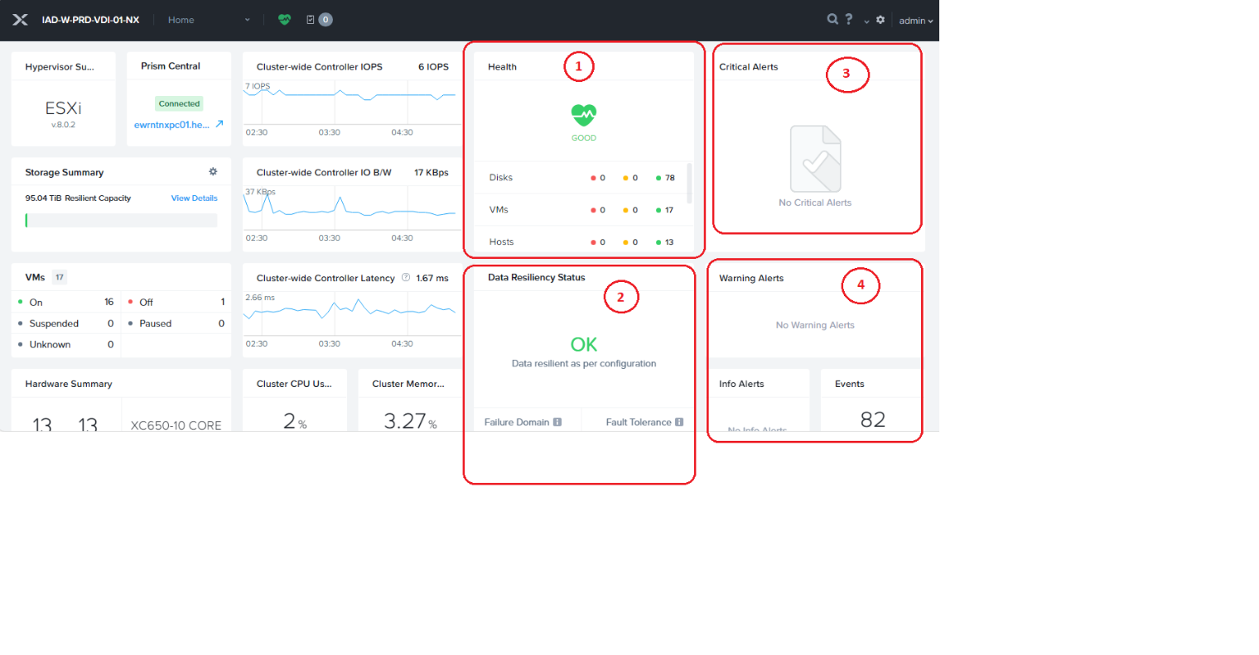

Above Screenshot is dashboard of prism element. Which give information in widgets as follows.

* 1st widget shows health status of cluster. (Good, Warning or Critical)
* 2nd widget displays Data Resiliency Status and Fault Tolerance Details (Good, Warning or Critical)
* 3rd widget shows Critical Alert details on cluster
* 4th widget details about Warnings, Info and events on cluster

Run health Check:

From the Prism web console **Health** page, select **Actions** > **Run Checks**. Select **All checks** and click **Run**.

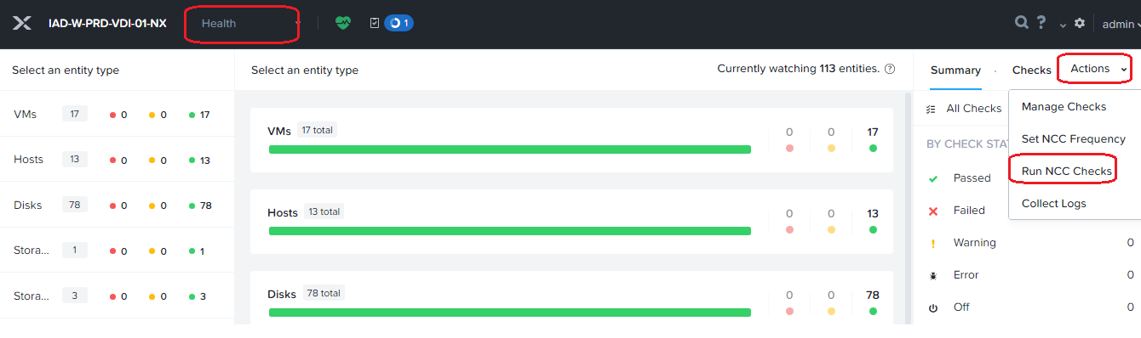

After completing this NCC it will display failed check on same page. As follows By default NCC run after every 4 hours

In above scenario there no issue occurred on cluster so displays no errors, NCC output can be anything as following and there meaning for any issue reported in NCC Check contact Nutanix SME or Nutanix Support.

## Alert Definition

Each NCC plugin is a test that completes independently of other plugins. Each test completes with one of these status types. The status might also display a link to a Nutanix Support Portal Knowledge Base article with more details about the check, or information to help you resolve issues NCC finds.

***PASS***

The tested aspect of the cluster is healthy and no further action is required. A check can also return a PASS status if it is not applicable

***FAIL***

The tested aspect of the cluster is not healthy and must be addressed. This message requires an immediate action. If you do not take immediate action, the cluster might become unavailable or require intervention by Nutanix Support.

***WARN***

The plugin returned an unexpected value that you must investigate. This message requires user intervention which you should resolve as soon as possible to help maintain cluster heath.

***INFO***

The plugin returned an expected value that however cannot be evaluated as PASS/FAIL. The plugin returns information about the tested cluster item. In some cases, the message might indicate a recommendation from Nutanix that you implement as soon as possible.

***ERR***

The plugin failed to execute. This message represents an error with the check execution and not necessarily an error with the cluster entity. It states that the check cannot confirm a PASS/INFO/WARN/FAIL status.

# Nutanix Cluster Management

For Nutanix Clusters Management is handled Via Prism Element and Prism Central.

## Storage Container Creation

A storage container is a subset of available storage within a storage pool. Storage efficiency features including compression, deduplication, and erasure coding are enabled at the container level

* Log on to the Prism Element web console.
* In the Storage dashboard, click the **Storage Container** button.

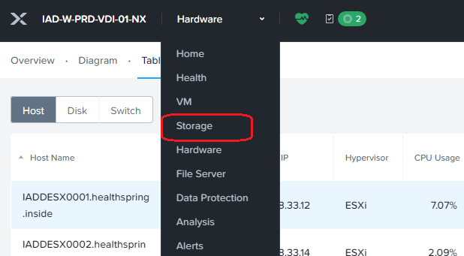

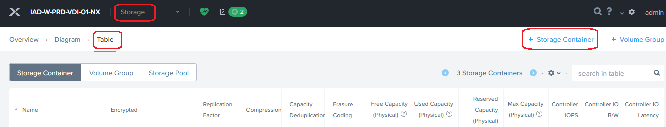

* The Create Storage Container dialog appears

Enter the following in the indicated fields:

* + **Name**: Enter a name for the storage container
  + **NFS Datastore**: Select the **Mount on all ESXi hosts** buttonA screenshot of a computer

    Description automatically generated
* click the **Advanced Settings** button

Enter the following in the indicated fields:

* + Replication Factor: Displays the number of data copies to maintain in the cluster. Nutanix supports a replication factor of 2 or 3.
  + **Compression**: Inline compression is enabled by default with the **Delay (In Minutes)** field set to 0
  + **Deduplication**: Select the **CAPACITY** check box to perform post-process deduplication of persistent data.
  + **Erasure Coding**: Select the **Enable** check box to enable erasure coding. Erasure coding increases the effective or usable capacity on a cluster.

* Click **Save** to Create Storage Container.

## Adding / Exiting Node in Maintenance Mode

* To add node in maintenance mode login to prism element and click on **“Hardware”** button.

* Then click on “Table” Tab. In Table tab select the server you want to put in maintenance mode and right click on sever then click on “Enter Maintenance Mode”

* Enter vCenter Details.

* After entering vCenter Details Click **Next** and then **“Enter Maintenance Mode”**

* Monitor the status of the task by clicking task button.

* After completing task successfully. It will appear in Green 100% status.

* Similar way you can exit the maintenance mode by selecting IP address of serve and then **“Exit Maintenance Mode”**

## Node Removal

**About this task**

Review the prerequisites for removing a node listed in [Prerequisites for Removing a Node](https://portal.nutanix.com/page/documents/details?targetId=Web-Console-Guide-Prism-v6_10:wc-prerequisites-node-remove-pc-c.html).

To remove a single node (host) from the cluster, do the following.

**Procedure**

* Log on to the Prism Element web console.
* Select the node you want to remove in one of the following ways:
  + In the Diagram page, select the target node (host).
  + In the Table page, click the Host tab and select the node (host).
* Click the **Remove Host** link on the right of the **Summary** line
* A dialog box appears to verify the action.
* Click the **OK** button in the confirmation dialog box.

If the node that you are trying to remove is unreachable or powered off, a notification is triggered in the Prism UI alerting you that the storage utilization for this node could not be calculated and also suggesting the possible impact of removing this node. If you still want to go ahead, you can use the force option to forcefully mark this node for removal.

After a node is removed, it goes into a state without any configuration. You can add such a node back into the cluster through the Expanding a Cluster workflow.

## Node Addition

You can add a node or host into the metadata store in events such as the aftermath of the replacement of a failed metadata disk.

**About this task**

Each node includes a disk used for metadata storage, and AOS maintains a metadata store across these disks to ensure uninterrupted resiliency should a metadata disk fail. After such a failure, that node is taken out of the metadata store group and the cluster continues to operate seamlessly without it. Normally, the node is brought back into the metadata store automatically after the failed metadata disk is replaced. However, under certain (rare) circumstances this might not happen. If the node is ready but was not added back automatically, you need to add the node back into the metadata store manually.

When the node is not added back automatically, the following alert message is displayed:

Node ready to be added to metadata store

To add a host into the metadata store, do the following.

**Procedure**

1. Log on to the Prism Element web console.
2. Select the node you want to add in one of the following ways:
   * Select the target node (host) in the diagram (Diagram view).
   * Click the **Host** tab and select that disk in the table (Table view).
3. Click the **Enable Metadata Store** link on the right of the **Summary** line.

The **Enable Metadata Store** link appears only when the node is not added back automatically, and the alert message is displayed

## Expansion of cluster

A cluster is a collection of nodes. You can add new nodes to a cluster at any time after physically installing and connecting them to the network on the same subnet as the cluster. The cluster expansion process compares the AOS version on the existing and new nodes and performs any upgrades necessary for all nodes to have the same AOS version.

* Log on to the Prism Element web console.
* Go to the Hardware dashboard and click the **Expand Cluster** button.

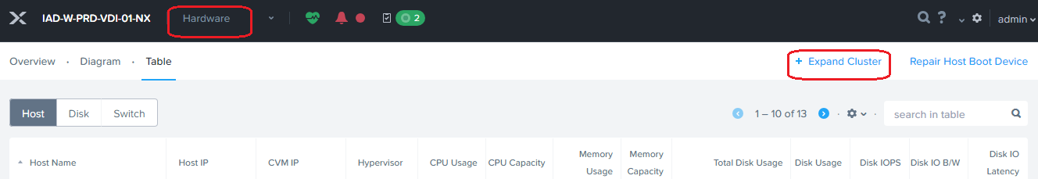

* In the Expand Cluster window, select (click the radio button for) the desired option and then click the **Next** button:
  + Select **Expand Cluster** to begin the expansion immediately (after you complete the remaining configuration steps).
  + Select **Prepare Now and Expand Later** to prepare the nodes now but delay adding them to the cluster until a later time. Preparing the nodes includes imaging the hypervisor (if needed), upgrading the AOS version (if needed), and preparing new node network configuration (if needed).

* Click Expand Cluster. And Next

* Select “Discover Host Manually”

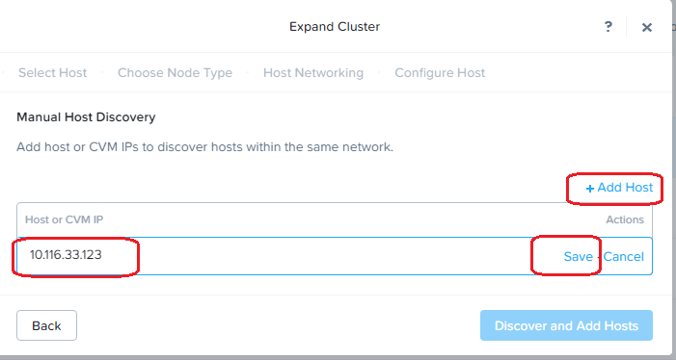

* Click on Add Host and add IP Address of CVM, then **“Discover And Add Host”**
* Select the checkbox for each block to be added to the cluster.
* Do the following in the indicated fields for each checked block
* **Host Name**
* **Controller VM IPv4**
* **Hypervisor IPv4**
* **IPMI IP IPv4**
* In the **Choose Node Type** tab, select the node type (**HCI Node** or **Storage-only**)
* In the **Host Networking** tab, configure the uplinks for each management bridge or vSwitch to be created or updated for the nodes.
* In the **Configure Host** tab, specify the hypervisor image
* When all the fields are correct, click the **Run Checks** button to verify that the nodes are ready.
* When the checks pass successfully, Click the **Expand Cluster** button to begin the cluster expansion process

## AOS Upgrade

The control plane (Prism) and data plane (AOS storage) are updated as part of an AOS upgrade. AOS upgrades typically offer several benefits, such as bug fixes, security updates, new features, and performance updates. AOS is typically the most upgraded layer in the Nutanix platform. You can perform these upgrades without moving VMs or upgrading the underlying hypervisor.

To begin the upgrade, select the checkbox for the AOS upgrade, click **View Update Plan**, review the plan, and click **Apply 1 Update**. LCM pulls the package directly from the Nutanix Support Portal.

**Procedure**

To access the LCM tool from Prism Element web console, perform the following steps:

* Log in to Prism Element web console.
* Select **LCM** from the navigation drop-down menu.

* Select the **Inventory** tab

* To take an inventory, click **Perform Inventory**.

* Once the Inventory operation completes, click **Return to Inventory**.

The new inventory appears on the **Inventory** page.

lick **View By** to switch the display between the host and component view.

* Once Inventory completed Nutanix will show you available **Software** and **Firmware** **Upgrade** in **Updates** tab, Click on Updates tab. And then on software or firmware.
* Click on Software and check mark on AOS option.

* Click on View Upgrade Plan.

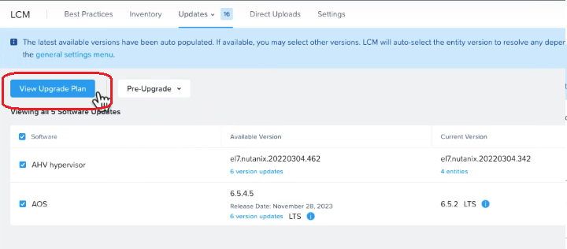

* After Clicking it will review the cluser details, then click Next

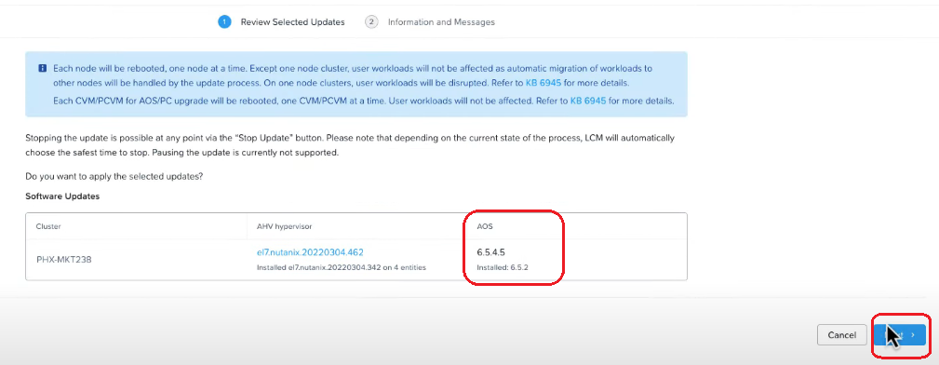

* On next page click on apply updates.

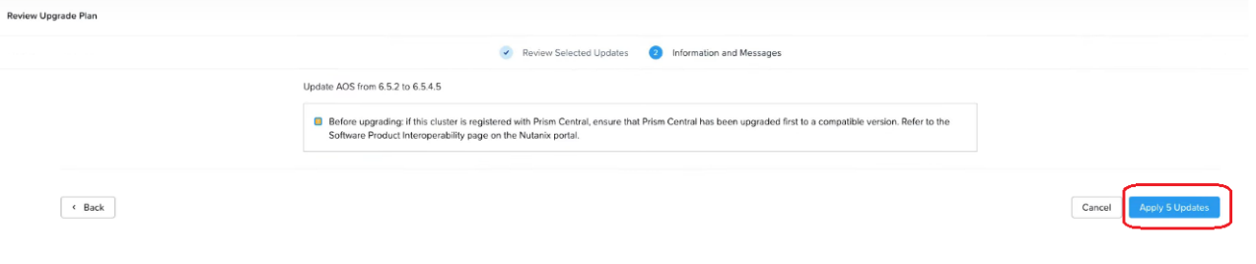

* After this AOS upgrade will start.

* Monitor the progress, After upgrading all nodes it will display successfully message

## Hypervisor Upgrade

These topics describe how to upgrade your ESXi hypervisor host through the Prism Element web console **Upgrade Software** feature.

**Procedure**

To access the **Upgrade Software** from Prism Element web console, perform the following steps:

* Log in to Prism Element web console.
* Select **Settings** from the navigation drop-down menu.

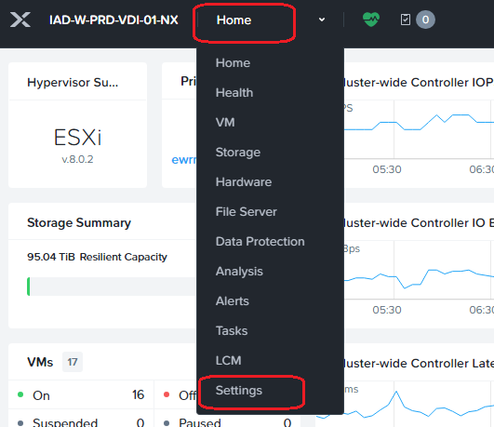

* On Setting page Go to general and click on Upgrade Software and then click on Hypervisor tab.

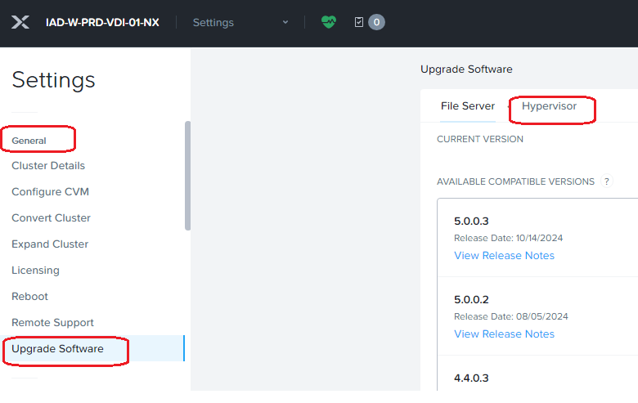

* On next page click on **“upload a Hypervisor binary”**

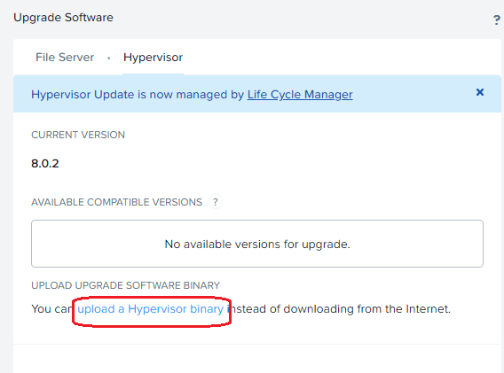

* On next page upload **Hypervisor Metadata file** and **Hyeprvisor Binary file**

Note: You can download Hypervisor Metadata file from portal.nutanix.com, also make sure you use only Nutanix qualified Hypervisor version which mentioned on Nutanix website.

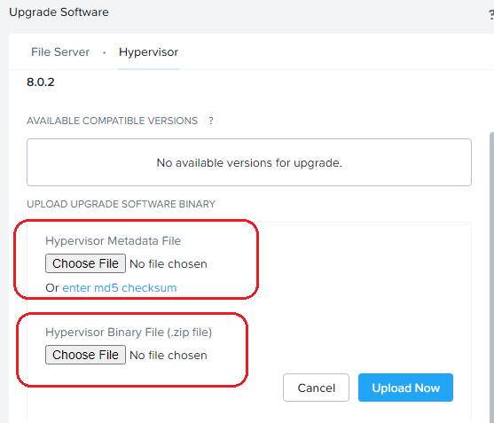

* Click on **Upgrade** button once upload completed.

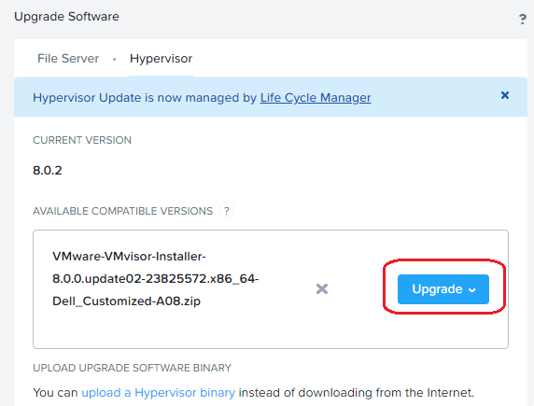

* Enter vCenter Details

* After this Hypervisor upgrade process start

## LCM Upgrade

LCM greatly simplifies infrastructure upgrades and version compliance. You can automatically update Nutanix Cluster Check (NCC) with LCM. We plan to expand this option to other software modules to mirror a cloud-like experience where all software is updated automatically.

In LCM you can perform all Nutanix component upgrade eg. AOS, AHV, FSM, Foundation, Prism, NCC, LCM etx

**Procedure**

To access the LCM tool from Prism Element web console, perform the following steps:

* Log in to Prism Element web console.
* Select **LCM** from the navigation drop-down menu.

* Select the **Inventory** tab

* To take an inventory, click **Perform Inventory**.

* Once the Inventory operation completes, click **Return to Inventory**.

The new inventory appears on the **Inventory** page.

lick **View By** to switch the display between the host and component view.

* Once Inventory completed Nutanix will show you available **Software** and **Firmware** **Upgrade** in **Updates** tab, Click on Updates tab. And then on software or firmware.
* Click on Software and check mark on AOS option.

* Click on View Upgrade Plan.

* After Clicking it will review the cluster details, then click Next

* On next page click on apply updates.

* After this AOS upgrade will start.

* Monitor the progress, After upgrading all nodes it will display successfully message

## TPM-ESXI Security Key Recovery Process

A ESXI Key recovery process may be required whenever a Field Engineer replaces a Server Motherboard, TPM fails or TPM is cleared.  This Process DOES NOT Apply to Dell XC Series Hardware as TPM is being disabled at factory.

* Provide the recovery key to the ONSITE Lenovo/IBM engineer who will handle the recovery.  The keys are centrally located on \\ciwafsxt0001\labrepo\nutanix\tpm-backups.  Note: You may need to search multiple TPM-RECOVERY-KEYS-7.txt. text files for the host recovery key.
* Start the ESXi host
* When ESXI installer appears, press Shift+O to edit boot options
* Append the following to any of the boot options: encryptionRecoveryKey=Host-Recovery-Key
* To persist the change, enter /sbin/auto-backup.sh

## Renewing Prism SSL Certificates.

Nutanix simplifies the SSL certificate import process into Prism web console.

Before you begin

Depending upon your requirements, you need to either generate a self-signed SSL certificate or generate a Certificate Signing Request (CSR) for submission to a certificate Authority (CA) to get a CA signed certificate.

**Procedure**

* + Log in to Prism Element as an administrator.
  + Click the gear icon in the main menu and in the Settings page, select SSL Certificate.

The SSL Certificate dialog box appears.

* + To replace an SSL certificate, click Replace Certificate.
  + To import self-signed SSL certificate or CA signed certificate, select Import Key and Certificate and then click Next.

**Private Key Type**: Select the appropriate private key type for the self-signed certificate from the dropdown list.

**Private Key**: Click Choose file and select the private key.

**Public Certificate**: Click Choose file and select the self-signed certificate corresponding to the private key.

**CA Certificate/Chain**: Click Choose file select the self-signed certificate corresponding to the private key.

* + To begin SSL certificate import, click **Import Files**.

**Results:**

After generating or importing the new certificate, the interface gateway restarts. If the certificate and credentials are valid, the interface gateway uses the new certificate immediately, which means that your browser session (and all other open browser sessions) is invalid until you reload the page and accept the new certificate. If anything is wrong with the certificate (such as a corrupted file or wrong certificate type), the new certificate is discarded, and the system reverts to the original default certificate provided by Nutanix.

## User addition Deletion

We have configured LDAP for role mapping with Prism Element access. LDAP Details and access provided as follows.

**LDAP:**

|  |  |
| --- | --- |
| **Directory Type** | Active Directory |
| **Name** | HealthSpring |
| **Domain** | healthspring.inside |
| **Directory URL** | ldaps://dcldap1.healthspring.inside:636 |
| **Service Account** | SVPNTNXADMIN_SVTN@healthspring.inside |
| **Service Account Password** | Cyberark |
|  |  |

**Role Mapping:**

|  |  |
| --- | --- |
| **Group** | Access |
| **E_ADM_IOCC_WIN_SERV** | Read Only |
| **E_ELV_A1_NUTANIX_ADMIN** | Admin |

## Server Device Issue

* A critical alert is generated when the Server device experience a device failure in vCenter or iDRAC or Prism Element or Prism Central.
* When the server fails, it could be because of motherboard or CPU failure or any other component.
* Inform the Guest OS team to verify if the application/vm is reachable. If it is an ESX host, ask VMware team to keep the Host in maintenance till fault is rectified.
* If the ESXi Host has a hardware failure, (*Referring Section 5.3*) log a case with Dell vendor to perform the replacement of the failed device.
* Coordinate with the vendor for the action plan and replace the faulty part.
* To schedule RMA (Referring Section 5.4.1) share the datacenter information and replacement time to Vendor to send parts and field engineer.
* Coordinate with the datacenter team to escort the field engineer
* Device location can be found in Datacenter layout section ( Section 5.4.1).
* Once the field engineer identifies the location of device through Serial No. the field engineer will proceed to replace the faulty part
* Field engineer will inform once the replacement is completed, and server is powered back on.
* Validate the server health post replacement from iDRAC and Prism Element.
* Once the replacement is completed, monitor the Host for sometime and exit the ESXi host from Maintenance Mode and Data Resiliency should be 'OK'
* Once the Cluster is balanced automatically by DRS , verify the Overall Cluster health by (*Referring Section 5.3*)running NCC.

### Memory Failure

**Symptoms:**

* When a memory failure occurs, Prism Element/iDRAC will display the alerts related to memory failure.

**Diagnosis:**

* Engage the Hardware Vendor.

**Shutting down the CVM and ESXi host**

1. Shut down or move or vMotion all VMs except for the Nutanix CVM. Power off the ESXi host you are installing the memory in.
2. In vCenter/Web Client, right-click on the ESXi host and select **Enter Maintenance Mode**.
3. In the *Confirm Maintenance Mode* dialog box, uncheck **Move powered off and suspended virtual machines to other hosts in the cluster** and click **Yes**. The host is placed in maintenance mode, which prevents VMs from running on the host.
4. Log in to CVM by using the vSphere console or SSH and shut down the CVM.  
   *nutanix@cvm$ cvm_shutdown -P now*
5. Right-click the ESXi host and select **Shut Down**.
6. When vCenter shows that the host is not responding, proceed to the next step.
7. You can check the details for failed DIMM from iDRAC or Dell Open manage portal

**Vendor will Physically add the DIMMs and confirm Nutanix Team.**

**Post Checks:**

1. Verify that ESXi boots up and reconnects to vCenter.
2. All the Hardware related alerts are resolved, and the Hardware should be 'Good' in iDRAC and Prism Element.
3. Monitor the Hardware for some-time and release the Host from Maintenance Mode.
4. Verify that the CVM boots up fully. Otherwise, click on the CVM and attempt to start the CVM.
5. Verify that the CVM participates fully in the cluster and that all cluster services are back in up state.
6. Check CVM is in maintenance mode or not by following command. If yes remove it form maintenance mode

*nutanix@cvm$* ncli host ls | egrep "Maint| Id| Name"|grep true -B2 ( To check)

*nutanix@cvm$ ncli host edit id=****<CVM_ID>*** *enable-maintenance-mode=false* (To exit cvm maintenance mode)

1. In Prism, go to the **Health** page and select **Actions** > **Run NCC Checks**.
2. In the dialog box that appears, select **All Checks** and click **Run**.  
   Alternatively, issue the following command from the CVM:  
   *nutanix@cvm$ ncc health_checks run_all*
3. *If you have any unresolvable failed checks, contact Nutanix Support.*

### HDDFailure

**Symptoms:**

* Disk Health alerts in Prism Element and in iDRAC.

**Diagnosis:**

* Contact the Hardware Vendor to replace the bad disk.
* Removing a disk in Prism Element takes time because the data on that disk must be migrated to other disks before it is removed from a node. Monitor the progress on the disk removal through the dashboard messages.

To remove a disk, do the following.

* Log on to the Prism Element web console.
* Select the disk you want to remove in one of the following ways:
  + Select the target disk in the diagram (Diagram view).
  + Click the Disk tab and select that disk in the table (Table view).
  + Click the Remove Disk link on the right of the Summary line.
  + A dialog box appears to verify the action.
  + Click the OK button in the confirmation dialog box.

*Caution: Do not physically remove a disk until that disk status indicator turns red in the diagram. The status message that appears on completion of the steps may indicate that the data migration is complete, but the disk is not ready for removal until that the disk status indicator turns red in the diagram.*

* The Vendor will insert the disk in an empty slot of the node.
* Select the added disk to view the details, "Repartition and Add" is selected, now re-partition and formatting the disk process starts. This will discard any remaining data, create a fresh new disk and the disk will get a new disk ID.
* Please re-run the full NCC health check, and it should Pass. If the check status remains as Fail, engage Nutanix Support to further validate the disk status.

# Nutanix basic command for troubleshooting.

We can separate document for basic command to check and troubleshoot Nutanix issue as follows:

[Nutanix Troubleshooting command.docx](https://cignatlp.sharepoint.com/:w:/r/sites/GovernmentDivestitureMigration/Shared%20Documents/Datacenter/Runbook%20and%20OPS/Compute/Nutanix/Nutanix%20Troubleshooting%20command.docx?d=w2a8d4e93c4e44d5d9ed3efb10b00500e&csf=1&web=1&e=MyK6iN)

# Link to other generic issues and troubleshooting KB articles

By visiting below KB article engineer can follows Nutanix guidelines for their respective issues.

|  |  |
| --- | --- |
| **Description** | **KB** |
| Which Alerts Automatically Generate a Support Case with Nutanix Support? | [KB 1959](https://portal.nutanix.com/kb/1959) |
| Alert - A111066 - Failed to send alert Emails | [KB 9937](https://portal.nutanix.com/kb/9937) |
| Troubleshooting alert emails not being sent | [KB 1288](https://portal.nutanix.com/kb/1288) |
| Support Portal Insight Discovery Overview and Troubleshooting | [KB 5782](https://portal.nutanix.com/kb/5782) |
| Nutanix Remote Support Tunnel Troubleshooting Guide | [KB 1044](https://portal.nutanix.com/kb/1044) |
| cvm_services_status verifies if a service has crashed and generated a core dump in the last 15 minutes. | [KB 2472](https://portal.nutanix.com/kb/2472) |
| cluster_services_status verifies if the Controller VM (CVM) services have restarted recently across the cluster. | [KB 3378](https://portal.nutanix.com/kb/3378) |
| LCM: (Life Cycle Manager) Troubleshooting Guide | [KB 4409](https://portal.nutanix.com/kb/4409) |
| HDD or SSD disk troubleshooting | [KB 1113](https://portal.nutanix.com/kb/1113) |
| check_ntp verifies the NTP configuration of the CVMs (Controller VMs) and hypervisor hosts, and also checks if there are any time drifts on the cluster. | [KB 4519](https://portal.nutanix.com/kb/4519) |
| Alert - A1050, A1008 - IPMIError | [KB 4188](https://portal.nutanix.com/kb/4188) |
| PE-PC Connection Failure alerts | [KB 6970](https://portal.nutanix.com/kb/6970) |
| Alert - A1054 - Node Marked To Be Detached From Metadata Ring | [KB 8408](https://portal.nutanix.com/kb/8408) |
| Alert - A6516 - Average CPU load on Controller VM is critically high | [KB 4272](https://portal.nutanix.com/kb/4272) |
| Alert "Link on NIC vmnic[x] of host [x.x.x.x] is down" being raised if an interface was used previously | [KB 2566](https://portal.nutanix.com/kb/2566) |
| Alert – FanSpeedLow | [KB 5132](https://portal.nutanix.com/kb/5132) |
| Alert - A120094 - cluster_memory_running_out_alert_insights | [KB 9605](https://portal.nutanix.com/kb/9605) |
| Alert - A700101 - Tomcat is restarting frequently | [KB 8524](https://portal.nutanix.com/kb/8524) |
| NX Hardware [Memory] – Checking the DIMM Part Number and Speed for ESXi, Hyper-V, and AHV | [KB 1580](https://portal.nutanix.com/kb/1580) |
| NCC Health Check: ipmi_sel_uecc_check/ dimm_sel_check | [KB 7177](https://portal.nutanix.com/kb/7177) |
| ipmi_sel_cecc_check fails even after replacement of bad DIMM | [KB 8474](https://portal.nutanix.com/kb/8474) |
| NCC Hardware Info: show_hardware_info | [KB 7084](https://portal.nutanix.com/kb/7084) |
| AHV host networking | [KB 2090](https://portal.nutanix.com/kb/2090) |
| Check that all metadata disks are mounted | [KB 4541](https://portal.nutanix.com/kb/4541) |
| Failed to update witness server with metro availability status for a protection domain | [KB 4376](https://portal.nutanix.com/kb/4376) |
| Health warnings detected in metadata service | [KB 7077](https://portal.nutanix.com/kb/7077) |
| Curator scan has failed | [KB 3786](https://portal.nutanix.com/kb/3786) |
| Disk capacity is above 90% | [KB 3787](https://portal.nutanix.com/kb/3787) |
| The drive has failed | [KB 6287](https://portal.nutanix.com/kb/6287) |
| One or more critical processes on a node are not responding to the rest of the cluster | [KB 3827](https://portal.nutanix.com/kb/3827) |
| This alert is generated when the 5-minute load average exceeds the threshold of 100 on a Controller VM | [KB 4272](https://portal.nutanix.com/kb/4272) |
| The Stargate process on a node has been down for more than 3 hours | [KB 3784](https://portal.nutanix.com/kb/3784) |
| The SATADOM has exceeded a wear threshold | [KB 4137](https://portal.nutanix.com/kb/4137) |
| ECC errors over the last day have exceeded the one-day threshold | [KB 4116](https://portal.nutanix.com/kb/4116) |
| ECC errors over the last 10 days have exceed the 10-day threshold | [KB 4116](https://portal.nutanix.com/kb/4116) |
| Hardware Clock Failure | [KB 4120](https://portal.nutanix.com/kb/4120) |
| A physical drive in the node has been reported as bad | [KB 4158](https://portal.nutanix.com/kb/4158) |
| One of the power supplies in the chassis has been reported down | [KB 4141](https://portal.nutanix.com/kb/4141) |
| A node in the cluster has an abnormally high temperature | [KB 4138](https://portal.nutanix.com/kb/4138) |
| SATA DOM in the node cannot be reached | [KB 7813](https://portal.nutanix.com/kb/7813) |
| SATA DOM in the node has failed | [KB 1850](http://portal.nutanix.com/kb/1850) |
| Number of Shell vDisks in the cluster is above the threshold | [KB 8559](https://portal.nutanix.com/kb/8559) |
| Check for number of UECC errors for last one day in the IPMI SEL | [KB 8885](https://portal.nutanix.com/kb/8885) |
| Incorrect LCM family can cause upgrade failure | [KB 9898](https://portal.nutanix.com/page/documents/kbs/details?targetId=kA00e000000brDFCAY) |
| LCM upgrade failed during reboot_from_phoenix stage | [KB 9437](http://portal.nutanix.com/kb/9437) |
| IPMI SEL UECC Check | [KB 8885](https://portal.nutanix.com/kb/8885) |
| Investigating ECCErrorsLast1Day and ECCErrorsLast10Days issues on a Nutanix NX nodes | [KB 4116](https://portal.nutanix.com/kb/4116) |
| Determine if a DIMM module is degraded. | [KB 3357](https://portal.nutanix.com/kb/3357) |
| Overview of Memory related enhancements introduced in BIOS: 42.300 or above for G6, G7 platforms | [KB 9137](https://portal.nutanix.com/kb/9137) |
| Understanding and enabling ePPR (extended Post Package Repair) for G6, G7 platforms | [KB 9562](https://portal.nutanix.com/kb/9562) |
| NX Hardware [Memory (CECC)] - G6, G7, G8 platforms - hPPR Diagnosis | [KB 11794](https://portal.nutanix.com/kb/11794) |
| NX Hardware [Memory] – G6, G7 platforms - DIMM Error handling and replacement policy | [KB 7503](https://portal.nutanix.com/kb/7503) |
| power_supply_check | [KB 7386](https://portal.nutanix.com/kb/7386) |